Determining Appropriate Risk Remediation Thresholds from Empirical Conjunction Data Using Survival Probability Methods

AAS 19-631

Doyle T. Hall[1]

Satellites sometimes maneuver before conjunctions to remediate the risk of an on-orbit collision. Many missions use probability of collision ($P_{c}$) thresholds to decide when such maneuvers should be performed. These thresholds tend to be conservative because of policies that require satellites survive their lifetimes without collision with high confidence (e.g., 99.9%). This study presents a semi-empirical method to estimate remediation $P_{c}$ thresholds that satisfy such lifetime risk requirements. The formulation combines survival probability analysis with empirical conjunction histories to estimate remediation thresholds as a function of satellite size, remaining on-orbit duration, lifetime collision probability limit, collision consequence, and other parameters.

Introduction

As the population of artificial Earth-orbiting satellites grows, the likelihood of on-orbit collisions also increases. Such collisions pose a direct threat to spacecraft occupied by humans, such as the International Space Station, as well as a much larger number of currently active robotic satellites, which represent significant investments by many international commercial, military and scientific organizations. Collisions also pose an indirect threat to future spacecraft, through the generation of fragmentation debris that can remain orbiting for extended periods. NASA’s Conjunction Assessment Risk Analysis (CARA) team has the responsibility to assess collision risks for a specific set of high value Earth-orbiting satellites.

When a tracked object is projected to approach a satellite of interest, a conjunction risk assessment analysis can be performed to quantify the risk of a collision. Many practitioners, including CARA, measure this likelihood with the probability of collision, $P_{c}$, determined using either semi-analytical1-3 or Monte Carlo methods.4,5 For high risk events, satellite operators may opt to perform a risk mitigation maneuver (RMM) to reduce the $P_{c}$ to a desired threshold. Some missions operate under stringent lifetime survival policies, which drive mitigation actions. These policies require that satellites survive their remaining active lifetimes at a high confidence level, such as 99.9%, without a large-object collision. In other words, conjunctions must be remediated in order to maintain a cumulative survival probability of $S_{cum}≥0.999$, thereby reducing the cumulative collision probability to $P_{cum}=1-S_{cum}≤{10}^{-3}$. Such policies not only help ensure that satellites provide a sufficient return on investment, they also enable reliable and responsible end-of-life disposal activities, which can prevent valuable orbital regions from accumulating inactive, debris-generating satellites.

This study presents a method to estimate conjunction remediation thresholds that satisfy such lifetime survival policy policies. Specifically, the formulation combines survival probability analysis with satellite conjunction histories in order to estimate risk remediation thresholds as a function of a satellite’s hard-body radius (HBR), on-orbit duration, and additional mission parameters. The semi-empirical method employs observed conjunction histories, each of which includes the orbital states and covariances for the comprehensive sequence of conjunctions experienced by an actual cataloged primary satellite over many years, as compiled in an archive database. These histories can be used to approximate cumulative collision probabilities for hypothetical, model objects flying in orbits similar to those of the observed primary satellites. The formulation allows the modeled satellites to have HBR values and mission lifetimes different than those of the original satellites.

The analysis indicates that semi-empirical cumulative collision probabilities, $P_{cum},$ increase significantly with increasing hard-body radius and remaining on-orbit duration. If $P_{cum}$ exceeds a mission’s lifetime threshold (e.g., $P_{cum}>{10}^{-3})$, then risk remediation actions must be included within the model, and the formulation provides a means to study how much $P_{cum}$ can be reduced by performing maneuvers. This in turn provides a means to estimate appropriate remediation threshold $P_{c}$ levels throughout a mission’s lifetime, as well as expected remediation maneuver frequencies. Finally, the study demonstrates the effects of incorporating collision “consequence” considerations6 that establish thresholds to remediate risk for only the most catastrophic collisions.

overview of cara conjunction RISK assessment and archived data

This section provides a brief overview of CARA risk assessment concepts and archived conjunction data, which are subsequently used to formulate the semi-empirical method of estimating cumulative collision probabilities.

Satellite Conjunction Histories

CARA assesses conjunction risk for several high-value satellites, and has been doing so for over a decade. During processing, the CARA system first detects candidate satellite close encounters seven to ten days in advance using a screening-volume approach7 incorporating the latest available tracking data and orbit determination (OD) solutions.8,9 This effort primarily employs the catalog of trackable satellites and associated OD solutions maintained by the United States Air Force.7,9 For each conjunction, CARA assesses collision risk using a suite of $P_{c}$ estimation methods1-5 which require as input the orbital states and associated covariance matrices for the primary and secondary satellites, as well as HBR values.

CARA’s archive database contains comprehensive, long-term records of the conjunctions experienced by several primary satellites. Each such “conjunction history” represents a sequential list of close approach events that represent screening volume incursions. For a particular CARA primary, each specific event can be identified uniquely using the secondary satellite’s space catalog number (SCN) and a nominal time of closest approach (TCA). Figure 1 illustrates a conjunction history for the Hubble Space Telescope (HST, SCN 20580) recorded over nearly a decade (2009-02-25 to 2019-01-29). The center panel, with date-dependent colored circles, shows the distribution of HST conjunctions as a function of altitude (horizontal axis) and latitude (vertical axis). Each circle represents a unique close approach event processed by the CARA system. Circle sizes indicate the amplitude of “last-update” $P_{c}$ estimates (as explained later in more detail). The left panel shows the frequency histogram of conjunctions as a function of latitude, indicating the well-known increase in conjunction rates at higher latitudes.10 HST’s orbital decay due to atmospheric drag can be seen in this plot, with the earliest conjunctions (blue circles) occurring at altitudes about 30 km higher on average than those occurring a decade later (yellow circles). Finally, Earth’s slightly pear-shaped figure (i.e., its J3 gravitational component) causes the distribution of events to skew slightly toward higher altitudes over the southern hemisphere (i.e., at negative latitudes).

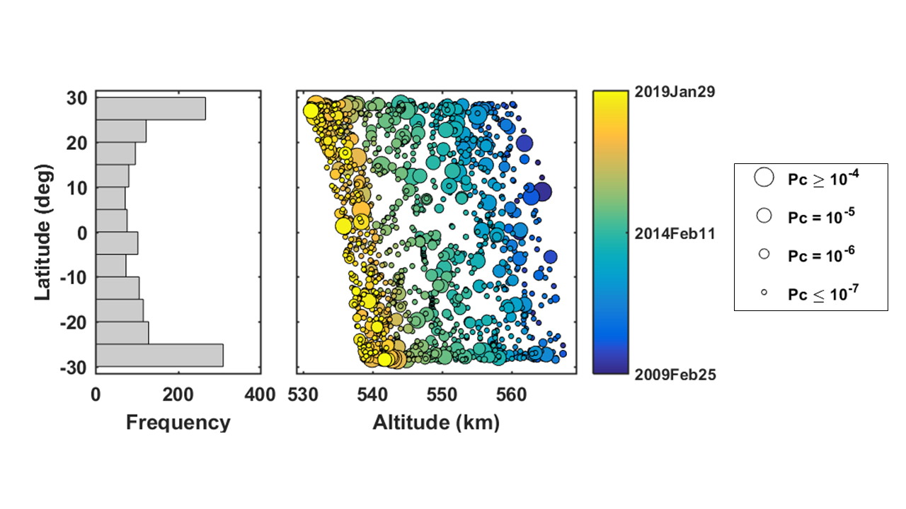

Figure 1. Illustration of a conjunction history spanning 9.92 years for the HST satellite, demonstrating how HST’s conjunctions with other cataloged objects are distributed in altitude, latitude, time, and estimated $P_{c}$ value.

Conjunction Update Sequences

As mentioned previously, the initial risk assessment processing by the CARA system can precede a conjunction’s nominal TCA by seven to ten days. Within a day or two of this first assessment, however, additional tracking observations of the primary or secondary objects become available ⎯ either due to the normal on-going sequence of catalog updates, or because of specially requested increased tracking sensor tasking. These produce new OD solutions, with refined orbital states and covariance matrices that, in turn, provide updated $P_{c}$ estimates. Several such updates often occur for each unique close approach event. Figure 2 shows a $P_{c}$ update sequence for an HST event that occurred in early 2016. The plot shows the sequential $P_{c}$ updates (vertical axis) plotted as a function of update time (horizontal axis). During such update sequences, $P_{c}$ estimates can vary dramatically. Notably, they often decrease significantly during the last 1-3 days before TCA, even without any active risk remediation, which naturally tends to result from the improving trend of orbital state prediction accuracies.11 In some cases, the final update found in CARA’s archive can even occur after TCA; these represent *post facto* risk assessments, and often employ the highest overall quality OD solutions available for a final analysis.

Risk Mitigation Maneuver Commit and Consider Times

Most missions need time to plan and execute maneuvers, and must *commit* to an RMM go/no-go decision somewhat before TCA. Such “RMM commit times” vary, but can be as short as a few hours for the most responsive missions, up to several days for the least. In addition, missions may also not even *consider* performing an RMM before a certain time, in order to avoid erroneous decisions and needless maneuver planning based on large orbital state prediction errors. Figure 2 illustrates a 1.5-day commit time ($τ_{cmt}=1.5 day$) and a 7-day consider time ($τ_{cns}=7 day$), plotted as two vertical dotted lines. RMM go/no-go decisions employ the most recent $P_{c}$ estimate available, which is the one in the update sequence immediately preceding the commit time. For the example shown in Figure 2, this “last update before the RMM commit time” (or just “last-update” for brevity) corresponds to $P_{c}=2.23×{10}^{-6}$, estimated ~6 hours before the commit time, and ~2 days before TCA.

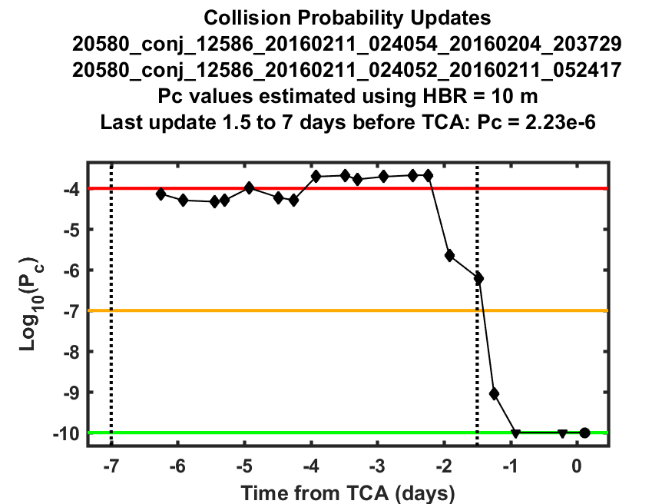

Figure 2. The $P_{c}$ update sequence for a conjunction between HST (SCN 20580) and a secondary object (SCN 12586) with a nominal TCA of 2016-02-11 02:41:52. Vertical dotted lines show examples of an RMM *commit time* (right) and *consider time* (left). Horizontal red, yellow and green lines show $P_{c}$ levels of 10-4, 10-7 and 10-10 for reference.

Risk Mitigation Maneuver Types

This analysis considers two types of risk mitigation maneuvers. *Translational* RMMs remediate collision risk by thrusting to alter the primary’s trajectory, and are usually quite effective in reducing risk because they are capable of reducing $P_{c}$ values to near-zero levels. *Rotational* RMMs have limited effectiveness because they only reorient the satellite and/or its articulating components to reduce the area projected toward the incoming object. Other RMM types, such as combined translational/rotational maneuvers, are not considered in this analysis. The HST satellite only has the capability to perform purely rotational RMMs.

Risk Mitigation Maneuver $P_{c}$ Thresholds

Many missions operate with “red” thresholds that indicate the $P_{c}$ level above which RMMs must be performed, coupled with “blue” thresholds (for translational RMMs) that determine the degree to which the $P_{c}$ must be reduced for the risk to be considered effectively remediated. (Note: blue thresholds do not apply to rotational RMMs because their degree of risk reduction is limited by reorienting to project minimum area.) For many current missions, these remediation thresholds are set at initial levels that appear to be sufficiently conservative, and then employed for entire satellite lifetimes without further quantitative justification or adjustment. The formulation presented in the next sections combines survival probability analysis with empirical conjunction histories to establish remediation thresholds as a function of satellite size, remaining on-orbit duration, lifetime collision probability limit, and other parameters.

Semi-empirical Cumulative survival and collision probabilities

The semi-empirical analysis presented here employs the observed conjunction history for a primary satellite as an empirical estimate of the set of events that could be experienced by a hypothetical, model mission occupying a similar orbit. As discussed in more detail later, the analysis assumes that the model mission executes translational RMMs using specified consider/commit time limits $(τ_{cmt},τ_{cns})$, in order to remediate risks for conjunctions that have last-update $P_{c}$ values exceeding a red threshold, denoted by $P_{RMM}$. For conjunctions that do not require an RMM (i.e., those with $P_{c}≤P_{RMM}$), the last-update $P_{c}$ value can be considered an estimate of the unremediated collision risk of the event. Collision risks from all such unremediated events accumulate over long periods on orbit. This section formulates how empirical cumulative collision probabilities can be estimated for model satellites that have an on-orbit duration equal to that of the observed primary, and in the limit $P_{RMM}→1$, for which no remediation occurs. The following section generalizes the semi-empirical model to enable analyses for different on-orbit durations and other red-threshold $P_{RMM}$ values.

Archived Long-Term Sequences of Conjunctions

The sequence of conjunctions observed to be experienced by an actual primary satellite during an extended on-orbit period

$T_{init}≤t≤T_{init}+T_{obs}$ (1)

can be easily identified within the CARA operational event database. The HST data set shown in Figure 1 spans an observation period of $T_{obs}$ = 9.92 years and includes a total of $N_{tot}=1,639$ unique events. For a model satellite occupying an HST-like orbit, however, only a subset of these events has a $P_{c}$ update within the mission’s specified RMM consider/commit time limits. This subset includes $N_{obs}=1,555$ events for $τ_{cmt}=1.5 day$ and $τ_{cns}=7 day$. In general, these $N_{obs}$ conjunctions involve many different secondary satellites, and are assumed to be statistically independent events for this analysis.

TCAs for the observed sequence of conjunctions can be denoted $t_{i}$ with $i=1…N_{obs}$. The corresponding TCA orbital state vectors ($X$) and state covariance matrices ($C$) for the primary and secondary satellites can be combined into a composite data set

$D_{obs}=\left\{X_{i}^{pri},C_{i}^{pri},X_{i}^{sec},C_{i}^{sec}\right\}$ (2)

The set $D_{obs}$ contains the essential conjunction sequence data for the semi-empirical formulation presented in this study, and can be extracted from the archive database for a specific primary using the four parameters $\left(T_{init},T_{obs},τ_{cmt},τ_{cns}\right)$.

The states and covariance matrices contained in $D_{obs}$ enable estimation of the sequence of last-update collision probabilities

$P_{c,i}=PcFunc\left(H,X_{i}^{pri},C_{i}^{pri},X_{i}^{sec},C_{i}^{sec}\right)$ (3)

with the combined set denoted $P_{obs}=\left\{P_{c,i}\right\}$, $i=1…N_{obs}$. The symbol $H$ in eq. (3) can represent the combined hard-body radii of the primary and secondary if both are known, $H=H^{pri}+H^{sec}$, or the protection radius used for all conjunctions involving the primary, $H=H^{prot}$. “ $PcFunc$” represents any viable $P_{c}$ estimation method, including semi-analytical1-3,11 or Monte Carlo formulations.4,5 This analysis employs the “2D-Pc” method1,2 to estimate $P_{c,i}$ values. (Note: the colored circles plotted in Figure 1 show the set $P_{obs}$ derived from the HST conjunction data using model mission parameters $H=10 m$, $τ_{cmt}=1.5 day$ and $τ_{cns}=7 day$).

Semi-Empirical Cumulative Collision Probability Estimation

Assuming no remediation maneuvers occur, the probability of surviving the *i*th event in a conjunction sequence without a collision can be estimated using the complement of the collision probability

$S_{c,i}=1-P_{c,i}$ (4)

The cumulative probability of surviving the entire sequence of conjunctions is given by the product of the individual survival probabilities, assuming they are statistically independent events

$S_{cum}\left(P\right)=\prod_{i=1}^{N}{\left[S_{c,i}\right]}=\prod_{i=1}^{N}{\left[1-P_{c,i}\right]}$ (5)

expressed here as a function of a generalized set of last-update collision probabilities, $P$. The cumulative collision probability is the complement of the cumulative survival probability

$P_{cum}(P)=1-S_{cum}(P)=1-\prod_{i=1}^{N}{\left[1-P_{c,i}\right]}$ (6)

This equation provides a semi-empirical estimate of the cumulative collision probability assuming no translational risk mitigation maneuvers had actually been performed. (This is a safe assumption for HST, because it is limited to purely rotational RMMs, which do not affect the archived TCA states and covariance matrices.) Applying eq. (6) to the $P_{obs}$ set illustrated in Figure 1 yields a cumulative collision probability of $P_{cum}^{obs}=P_{cum}\left(P_{obs}\right)=6.8×{10}^{-3}$ for model mission parameters $H=10 m$, $τ_{cmt}=1.5 day$ and $τ_{cns}=7 day$. This implies that a hypothetical satellite in or near HST’s orbit with these model mission parameters would have accumulated ~0.7% probability of colliding with another cataloged object during this ten-year period, had it performed no RMMs. If such a mission had a requirement of keeping the cumulative probability at or below a level of ${P_{cum}^{goal}=10}^{-3}$ during this period, it would have needed to perform RMMs to achieve this goal.

Semi-Empirical Cumulative Collision RISK Model

This section illustrates how the semi-empirical approach can be extended to provide approximations for model satellites with different on-orbit durations, $T_{mod}≠T_{obs}$, and to allow combining multiple primaries occupying similar orbits to enlarge the input pool of conjunction data. These generalizations first employ a scaling method to approximate the cumulative number of conjunctions experienced by a model satellite, $N_{mod}$, followed by a resampling approach to generate multiple realizations of the model state/covariance sequence, $D_{mod}$, and the associated collision probability sequence, $P_{mod}$.

Scaling the Cumulative Number of Conjunctions

The cumulative number of conjunctions expected for a model satellite occupying an orbit similar to an observed primary’s orbit can be approximated by applying two scale factors

$N_{mod}≈N_{obs}×\left[\frac{T_{mod}}{T_{obs}}\right]×\left[\frac{1}{N_{pri}}\right]$ (7)

The first factor in square brackets scales the number of events by the ratio of the model mission duration to the observation duration. The second factor in square brackets allows data from multiple primaries to be combined. For instance, the CARA archive contains conjunction data for the two identical GRACE satellites.12 During their active mission, this pair occupied congruent polar orbits, with one leading the other by about 220 km. Because of this, the archived conjunction data for this pair could be combined for a semi-empirical analysis, and $N_{pri}$ set to two in eq. (7). The CARA archive contains data for other satellite groups and constellations that can be combined similarly.

Applying these two scale factors implicitly assumes that the distribution of states/covariance matrices for conjunctions experienced by the model satellite will be the same as (or sufficiently similar to) the distribution observed for the actual primary, or primaries, if $N_{pri}>1$. In other words, the data in Figure 1 can be used for semi-empirical approximations only for model satellite missions deployed into HST-like orbits, and interacting with a similar secondary population. This study applies the first scale factor in eq. (7), in order to study the effect of varying the mission durations. Application of the second factor is reserved for future analysis.

Resampling to Generate Multiple Model Conjunction Sequence Realizations

As mentioned previously, an observed conjunction sequence has archived TCA orbital states and covariance matrices specified by the set $D_{obs}$ given in eq. (2). This set can be resampled to construct one or more sequences that can be applied to a model mission. The first step of this process is to generate a set of resampling indices, {$i_{j}\}$, with $j=1…N_{mod}$, which represent randomly-selected integers distributed uniformly over the range $1≤i_{j}≤N_{obs}$ produced using a sampling-with-replacement algorithm that allows repeated integer values. These indices are then used to create a resampled state/covariance sequence applicable to a model mission

$D_{mod}=\left\{X_{i_{j}}^{pri},C_{i_{j}}^{pri},X_{i_{j}}^{sec},C_{i_{j}}^{sec}\right\}$ (8)

Repeating this randomized sampling process generates multiple such model sequences $D_{mod,k}$ with $k=1…K$, where $K$ represents the number of resampling realizations used in the analysis. Each set $D_{mod,k}$ represents a synthetic realization of the conjunction sequence experienced by the model satellite, and provides the means to estimate the associated set of collision probabilities $P_{mod,k}$ using eq. (3), which in turn can be used to estimate the cumulative probability $P_{cum,k}$ using eq. (6). The multiple sampling realizations can be combined to produce a median estimate

$P_{cum}^{mod}=median(P_{cum,k})$ (9)

Variations associated with the sampling process can be measured using the bounds on the central 95% of the range spanned by the set {$P_{cum,k}\}$.

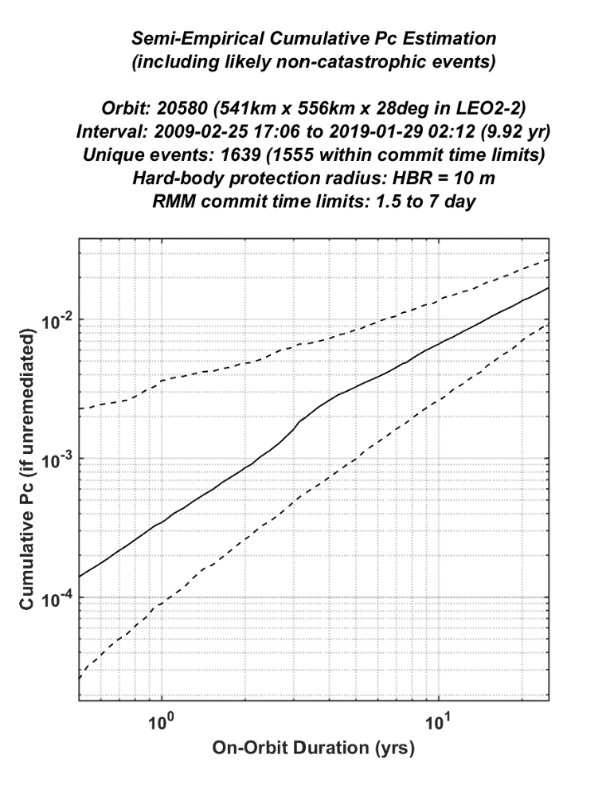

Figure 3. Semi-empirical cumulative collision probabilities estimated as a function of on-orbit duration for a model mission deployed into an HST-like orbit, assuming no remediation maneuvers are performed. The solid line shows median estimates for 1,000 resampling realizations; dashed lines show bounds for the central 95% of the realizations.

Applying the Semi-Empirical Model to the Observed Primary Satellite

The self-consistency and sampling variations of the semi-empirical model can be tested by estimating the cumulative probability for observed time period, i.e., $T_{mod}=T_{obs}$. For this test, both scale factors in eq. (7) equal one, so $N_{mod}=N_{obs}$. However, the resampling process produces conjunction sequence realizations with $P_{mod,k}≠P_{obs}$. Generating *K* = 1,000 resampling realizations from the HST data shown in Figure 1 yields a median estimate of $P_{cum}^{mod}=6.6×{10}^{-3}$ with the central 95% spanning the range ($2.8-12.6)×{10}^{-3}$ (for model parameters $T_{mod}=9.92 year,$ $H=10 m$, $τ_{cmt}=1.5 day$, and $τ_{cns}=7 day$). This is consistent with the estimate reported previously of $P_{cum}^{obs}=6.8×{10}^{-3}$ calculated directly from $P_{obs}$. Notably, the 95% sampling range spans scale factors of ~1.9 above and ~2.4 below the median, indicating that this semi-empirical method can only provide rough estimates for cumulative probabilities. These sampling ranges can be reduced (but not eliminated) by using larger conjunction data sets, which can be created by extending the observation durations and/or combining multiple primaries.

Figure 3 shows $P_{cum}^{mod}$ estimates and 95% sampling ranges calculated by varying model on-orbit durations over the range $0.5≤T_{mod}≤25$ years (but retaining $H=10 m$, $τ_{cmt}=1.5 day$, and $τ_{cns}=7 day$). It sensibly demonstrates that cumulative collision probability estimates decrease as on-orbit durations decrease. This means that for sufficiently short durations, $P_{cum}^{mod}$ could become less than a mission’s cumulative risk goal value of $P_{cum}^{goal}$. During such short missions no remediation may be required at all within the model. As can be seen in Figure 3, for a cumulative $P_{c}$ goal value of $P_{cum}^{goal}={10}^{-3}$, this short-duration limit occurs at $T_{mod}≤2.3 years$ for the median $P_{cum}^{mod}$ values estimated in this example.

Although it provides rough estimates, this generalized semi-empirical model enables sensitivity analyses that could aid pre-launch mission risk assessments. For instance, Figure 3 indicates that a mission planning to launch into HST’s orbital regime with a 5-year on-orbit duration and a 10 m HBR would expect to accumulate a collision risk of $P_{cum}^{mod}≈3.2×{10}^{-3}$ with a 95% range spanning ($1.0-8.5)×{10}^{-3}$, if no RMMs were performed. For this example, the model indicates that reducing the HBR by half to 5 m decreases these cumulative probabilities by a factor of ~4. More broadly, the model indicates that, for typical satellite HBR values, cumulative collision probabilities scale very nearly in proportion to the hard-body sphere’s projected area (i.e., $P_{cum}^{mod}∝H^{2}$), as do the individual conjunction $P_{c}$ values. These examples show how prospective missions can gauge cumulative collision risk over a trade-space of satellite and mission parameters.

Cumulative Collision Probability Model with Risk Remediation

The previous sections calculated cumulative collision probabilities based on the assumption that the model mission performs no risk mitigation maneuvers (i.e., for a limiting red threshold of $P_{RMM}→1$). The effect of remediating collision risk by performing RMMs can be incorporated into the semi-empirical model by modifying eq. (6) to express the remediated cumulative probability

$P_{cum}^{rem}=P_{cum}(P_{rem})=1-\prod_{i=1}^{N_{mod}}{\left[1-P_{c,i}^{rem}\right]}$ (10)

where the remediated collision probability for the *i*th model conjunction is

$P_{c,i}^{rem}=\left\{\begin{matrix}P_{c,i} & for P_{c,i}≤P_{RMM} (no RMM required) \\ ρ_{r }P_{c,i} & for P_{c,i}>P_{RMM} and rotational RMM type \\ {ρ_{t }P}_{RMM} & for P_{c,i}>P_{RMM} and translational RMM type\end{matrix}\right.$ (11)

and $P_{rem}=\{P_{c,i}^{rem}\}$ represents the entire set comprising $N_{mod}$ probabilities. As mentioned previously, $P_{RMM}$ denotes the “red” collision probability threshold in eq. (11). The factors $ρ_{r}$ and $ρ_{t}$ represent the $P_{c}$ reduction levels achieved by rotational and translational maneuvers, respectively. Eq. (11) corresponds to a risk remediation policy of performing RMMs for all events with last-update collision probabilities exceeding the red threshold. Eq. (11) also shows the different nature of the $P_{c}$ reduction factors for translational and rotational RMM types. Specifically, rotational maneuvers can only reduce the primary’s area projected toward the incoming secondary, thereby decreasing the collision probability by a finite amount approximately equal to the ratio of areas

$ρ_{r}={(A}_{proj})/(πH^{2})$ (12)

where $A_{proj}$ is the reduced projected area. Translational maneuvers, on the other hand, have the capability to reduce probabilities to very small levels (i.e., effectively to zero), depending on how early they are performed and how much change in velocity is applied. For translational RMMs, the product ${ρ_{t }P}_{RMM}$ represents the blue remediation threshold in this analysis. Remediating to an exceedingly small $ρ_{t}$ value such as ≤10-6 could conceivably require prohibitively early or large maneuvers. However, as discussed later, remediating $ρ_{t}$ to more moderate values such as 0.03-0.1 provides comparable collision risk reduction, and potentially allows more efficient translational RMMs to be scheduled and executed.

Risk Mitigation Maneuver Execution Rates

The average rate that a mission performs maneuvers in the model is given by

${\dot{N}}_{RMM}={\left[\sum_{i=1}^{N_{mod}}{U(P_{c,i}-P_{RMM})}\right]}/{T_{mod}}$ (13)

measured here in RMMs per year. Here $U(x)$ denotes the step function

$U\left(x\right)=\left\{\begin{matrix}0 & for x≤0 \\ 1 & for x>0\end{matrix}\right.$ (14)

Because performing maneuvers often requires expending limited and valuable mission resources (e.g., fuel and labor), average ${\dot{N}}_{RMM}$ rates provide a convenient measure of the burden imposed by remediating to different levels of cumulative collision risk.

Regular vs Conservative Model Estimates

For missions with perfectly safe and reliable maneuver execution systems, the type of conjunction that produces the most unremediated risk has collision probability equal to the red threshold, i.e., $P_{c,i}=P_{RMM}$. Eq. (11) indicates that an RMM would just barely not be performed in this case, assuming strict adherence to the risk remediation policy. Facing this prospect, a conservative satellite owner/operator may want to insist that, even if such an event were to occur, the mission would still confidently be operating within the imposed on-orbit cumulative risk limit. This concept forms the basis of the “conservative” mode of the model, which adds one threshold-level event to each model sequence of collision probabilities, $P_{rem}^{cons}=\left\{P_{RMM},P_{rem}\right\}$, and uses this augmented set for estimation, instead of the original set $P_{rem}$ employed by the model’s “regular” mode.

Estimating Remediation Thresholds and maneuver Rates

The semi-empirical model formulated in the previous sections provides the means to estimate remediation thresholds and maneuver rates. Figure 4 graphically illustrates the estimation process for a model satellite in an HST-like orbit performing translational RMMs with the mission parameters $ρ_{t}=0.03$, $H=10 m$, $τ_{cmt}=1.5 day$, and $τ_{cns}=7 day$. (Note: Unless otherwise stated, this “standard” set of mission parameters will be used repeatedly in the following sections for many example analyses, including Tables 1-4.) The left panel in Figure 4 shows regular estimation mode solutions, and the right panel conservative mode solutions. Each panel shows median remediated cumulative probabilities ( $\log_{10}{[P_{cum}^{rem}]}$ as measured along the color axis and with contour lines) estimated as a function of remaining on-orbit duration ( $T_{mod}$ on the vertical axis) and red remediation threshold ( $\log_{10}{[P_{RMM}]}$ on the horizontal axis). A close inspection of the contours in Figure 4 indicates that the largest differences between regular and conservative mode threshold estimates occur for the shortest mission durations.

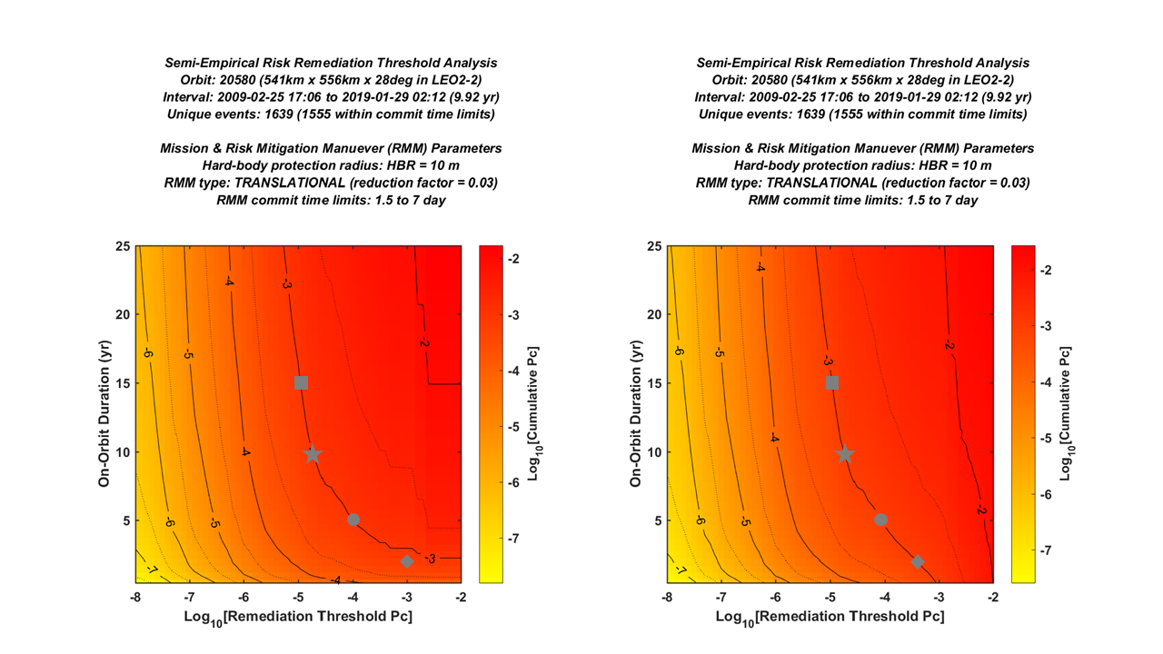

Figure 4. Remediated cumulative collision probabilities for the regular mode (left panel) vs the conservative mode (right panel), for the “standard” example mission parameters (see text). Each panel shows median $P_{cum}^{rem}$ values (in color with contours) estimated as a function of on-orbit duration (vertical axis) and red remediation threshold (horizontal axis).

Variation of Remediation Thresholds and Rates with Mission Duration

Unsurprisingly, the model indicates that missions with long remaining on-orbit durations need to perform more remediation actions (at least initially, as discussed below) in order to achieve the same level of cumulative collision risk compared to those with shorter durations. The gray symbols in Figure 4 demonstrate this effect explicitly by showing solutions that remediate to a cumulative risk goal level of ${P_{cum}^{goal}=10}^{-3}$. Specifically, gray diamonds, circles, stars and squares show solutions for durations of 2, 5, 10 and 15 years, respectively. Table 1 lists the corresponding median $P_{RMM}$ and average ${\dot{N}}_{RMM}$ values. Table 1 indicates that average maneuver rates, ${\dot{N}}_{RMM}$, change non-linearly with remaining on-orbit duration, $T_{mod}$; it also confirms that the largest differences between regular and conservative estimates occur for the shortest durations.

Notably, all of the gray symbols in Figure 4 lie along the $\log_{10}{[P_{cum}^{rem}]}=-3$ contours on the plots except for one: the $T_{mod}=2 year$ solution from the regular estimation mode, which falls below the $T_{mod}≤2.3 year$ short-duration limit apparent in Figure 3, as discussed previously. For such short-duration limiting cases, the regular estimation mode of the model sets the red remediation level to the cumulative goal value, i.e., $P_{RMM}=P_{cum}^{goal}$. The conservative mode of the model, however, does not encounter such cases by design, so its solutions all lie exactly on the contour corresponding to $P_{cum}^{goal}$, as shown in the right panel of Figure 4.

Table 1. RMM median thresholds $P_{RMM}$ and average rates ${\dot{N}}_{RMM}$ estimated using the “standard” mission parameters (see text) with a cumulative risk goal of $P_{cum}^{goal}={10}^{-3}$.

|  |  |  |  |  |  |
| --- | --- | --- | --- | --- | --- |
|  | Remaining  On-orbit  Duration $T_{mod}$ (yr) | Regular Mode  Estimates | | Conservative Mode  Estimates | |
|  | (yr-1) |  | (yr-1) |
| Reduction  factor | 2 | 1.00×10-3 | 0.21 | 4.09×10-4 | 0.31 |
| 5 | 1.05×10-4 | 0.87 | 8.53×10-5 | 1.05 |
| 10 | 1.89×10-5 | 3.33 | 1.82×10-5 | 3.43 |
| 15 | 1.11×10-5 | 5.69 | 1.10×10-5 | 5.70 |
| Reduction  factor | 2 | 1.00×10-3 | 0.21 | 4.12×10-4 | 0.31 |
| 5 | 1.08×10-4 | 0.85 | 8.76×10-5 | 1.02 |
| 10 | 1.95×10-5 | 3.22 | 1.89×10-5 | 3.33 |
| 15 | 1.15×10-5 | 5.52 | 1.13×10-5 | 5.59 |

Variation of Remediation Thresholds and Rates with the $P_{c}$ Reduction Factor

Table 2 shows the effect of changing the reduction factor for translational maneuvers from the standard value of $ρ_{t}=0.03$ for the 5-year mission duration models plotted as the gray circles in Figure 4. Decreasing $ρ_{t}$ from this value has the effect of slightly decreasing the rate that RMMs must be performed in order to attain the same level of cumulative risk. However, it also makes blue threshold levels more difficult to achieve by potentially requiring prohibitively early or large maneuvers. Increasing $ρ_{t}$ has the opposite effect. Table 2 demonstrates that, for this example case, $ρ_{t}$ values in the range 0.03 to 0.1 can be used to achieve the same levels of risk remediation as the most stringent value of $ρ_{t}=0$, but only increase ${\dot{N}}_{RMM}$ averages by less than 3% to 10%, respectively. Similar comparisons for other CARA primaries also indicate that using a blue threshold reduction factor of $ρ_{t}=0.03$ provides effective risk remediation without increasing average maneuver rates by more than ~5%.

Table 2. RMM median thresholds $P_{RMM}$ and average rates ${\dot{N}}_{RMM}$ as a function of reduction factor $ρ_{t}$ for a mission required to remediate to a 5-year cumulative risk of $P_{cum}^{goal}={10}^{-3}$.

|  |  |  |  |  |  |  |
| --- | --- | --- | --- | --- | --- | --- |
|  | | $ρ_{t}$ =0.30 | $ρ_{t}$ =0.10 | $ρ_{t}$ =0.03 | $ρ_{t}$ =0.01 | $ρ_{t}$ =0.00 |
| Regular  Mode |  | 7.77×10-5 | 9.76×10-5 | 1.05×10-4 | 1.07×10-4 | 1.08×10-4 |
| (yr-1) | 1.14 | 0.93 | 0.87 | 0.86 | 0.85 |
| Conservative  Mode |  | 6.69×10-5 | 7.95×10-5 | 8.53×10-5 | 8.68×10-5 | 8.76×10-5 |
| (yr-1) | 1.33 | 1.11 | 1.05 | 1.03 | 1.02 |

Variations of Remediation Thresholds and Rates with Hard-Body Radius Values

Table 3 shows the effect of changing the hard-body radius from the standard value of $H=10 m$ for a 5-year on-orbit duration. Not surprisingly, the model indicates that satellites with larger hard-body radii need to perform significantly more remediation to achieve the same level of cumulative collision risk compared to those with smaller radii. For instance, Table 3 shows that enlarging $H$ from 10 m to 20 m increases expected remediation rates by a factor of ~7 or more ⎯ indicating that ${\dot{N}}_{RMM}$ growth can exceed even the $H^{2}$ trend that applies to most collision probabilities. This implies that simply flying smaller satellites provides an extremely effective means of reducing both remediation activities and on-orbit collision risks. It also emphasizes that missions should use realistic and accurate hard-body radii to assess risks; artificially inflated $H$ values can unnecessarily increase both risk assessment workloads and remediation activities.

Table 3. RMM median thresholds $P_{RMM}$ and average rates ${\dot{N}}_{RMM}$ as a function of HBR for a mission required to remediate to a 5-year cumulative risk of $P_{cum}^{goal}={10}^{-3}$.

|  |  |  |  |  |  |
| --- | --- | --- | --- | --- | --- |
|  | | $H$ =2.5m | $H$ =5m | $H$ =10m | $H$ =20m |
| Regular  Mode |  | 1.00×10-3 | 1.00×10-3 | 1.05×10-4 | 3.00×10-5 |
| (yr-1) | < 0.01 | < 0.01 | 0.87 | 7.48 |
| Conservative  Mode |  | 7.96×10-4 | 4.64×10-4 | 8.53×10-5 | 2.89×10-5 |
| (yr-1) | < 0.01 | 0.10 | 1.05 | 7.67 |

Variations of Remediation Thresholds and Rates with Maneuver Commit Times

Table 4 shows the effect of changing remediation maneuver commit times from the standard value used here of $τ_{cmt}=1.5 day$ s for 5-year durations. The model indicates that missions with shorter commit times need to perform less remediation to achieve the same level of cumulative risk. For instance, Table 4 shows that reducing $τ_{cmt}$ from 1.5 days to 0.25 days (i.e., from 36 hours to 6 hours) decreases expected remediation rates by a factor of ~3.3 or more. This implies that implementing more responsive mission maneuver systems also provides an effective means of reducing both remediation activities and on-orbit collision risks.

Variations in the remediation maneuver consider times can also be investigated, specifically to study the implications of using somewhat more realistic values for $τ_{cns}$ of 3 to 5 days, rather than the default value of 7 days used for all examples discussed here.

Table 4. Median RMM thresholds $P_{RMM}$ and average rates ${\dot{N}}_{RMM}$ as a function of commit time $τ_{cmt}$ for a mission required to remediate to a 5-year cumulative risk of $P_{cum}^{goal}={10}^{-3}$.

|  |  |  |  |  |  |
| --- | --- | --- | --- | --- | --- |
|  | | $τ_{cmt}$ =0.25 day | $τ_{cmt}$ =0.5 day | $τ_{cmt}$ =1.0 day | $τ_{cmt}$ =1.5 day |
| Regular  Mode |  | 2.28×10-4 | 1.30×10-4 | 1.18×10-4 | 1.05×10-4 |
| (yr-1) | 0.15 | 0.47 | 0.56 | 0.87 |
| Conservative  Mode |  | 1.16×10-4 | 1.03×10-4 | 9.62×10-5 | 8.53×10-5 |
| (yr-1) | 0.32 | 0.66 | 0.74 | 1.05 |

Adjusting Remediation Thresholds During A Satellite’s Active Lifetime

Figure 4 and Table 1 indicate that $P_{RMM}$ and ${\dot{N}}_{RMM}$ estimates change significantly with remaining on-orbit duration. This means that, as a mission progresses throughout its lifetime, it could adjust its red remediation threshold on an on-going basis, and still continuously satisfy the same cumulative risk goal for its remaining on-orbit duration. For instance, a newly-launched 5-year duration mission in an HST-like orbit could initially perform remediation using a median conservative-mode threshold of $P_{RMM}=8.53{10}^{-5}$ and expect an associated average maneuver rate of ${\dot{N}}_{RMM}≈1.05$ per year (as listed in Table 1 for $ρ_{t}=0.03$). After surviving 3 years, however, the same mission would have only two years remaining on-orbit, and could then use a less demanding conservative-mode threshold of $P_{RMM}=4.09{10}^{-4}$ reducing the average maneuver rate to ${\dot{N}}_{RMM}≈0.31$ per year (also as listed in Table 1), and still satisfy its $P_{cum}^{goal}={10}^{-3}$ requirement.

Remediation Thresholds Excluding Likely Non-Catastrophic Events

The examples presented so far have included all conjunctions with tracked secondary objects, regardless of the severity or consequences of collision that might result. Methods exist, however, to evaluate the likelihood of a “catastrophic” collision, in which both the primary and secondary fragment fully, and thereby add significantly to the orbital debris population (see Lechtenberg and Hejduk6 and references therein). This concept allows risk management policies to focus on preserving valuable orbital regions by preventing the accumulation of debris that threaten other current and future missions; it also forms the basis of the “environment protection” modes of the semi-empirical model formulation, as opposed to the “mission protection” modes discussed previously.

Preliminary analysis indicates that implementing an environment protection mode that excludes collisions estimated to be non-catastrophic at a conservative 99.9% confidence level6 can significantly change required remediation thresholds and rates, depending on the primary’s mass and orbital environment. For instance, assuming a 2,000 kg primary, 590 of the 1,555 conjunctions shown in Figure 1 would be evaluated as likely non-catastrophic collision events. In this case, the 5-year model mission discussed previously with conservative-mode/mission-protection remediation estimates of $P_{RMM}=8.53{10}^{-5}$ and ${\dot{N}}_{RMM}≈1.05$ per year (as listed in Table 1 for $ρ=0.03$), would have much less stringent conservative-mode/environment-protection remediation estimates of $P_{RMM}=2.18{10}^{-4}$ and ${\dot{N}}_{RMM}≈0.36$ per year.

The CARA team continues to study how to incorporate collision consequence considerations into the semi-empirical model. For instance, rather than focusing on a catastrophic vs non-catastrophic collision evaluation, the model could employ an “expected number of generated fragments” metric as a more quantitative measure of orbital environmental protection.

Discusssion

The semi-empirical method presented here estimates conjunction remediation thresholds that allow satellites to survive their remaining on-orbit lifetimes without experiencing a cataloged-object collision at a quantified confidence level, such as 99.9%. The biggest advantage of the semi-empirical approach is that the orbital states and covariances required for collision probability estimation can be taken directly from a conjunction archive, such as that maintained by CARA, which includes data for many primary satellites compiled over an extended period. This eliminates the need to simulate these conjunction quantities realistically, which can be very difficult, especially for orbital state covariances. The semi-empirical formulation scales and resamples observed state/covariance sequences so that cumulative probabilities can be estimated for hypothetical model satellites that differ from the original observed primaries. This enables sensitivity analyses for a variety of model mission parameters, such as hard-body radius, on-orbit duration, and maneuver commit/consider times. The biggest disadvantage of the semi-empirical approach is that relies on three restrictive assumptions: 1) the model satellites deploy into (or sufficiently near) orbits occupied by a primary satellite contained in the archive, 2) the model satellites interact with the same (or a sufficiently similar) secondary population as the original primary satellite, and 3) that the distribution of states/covariances for conjunctions experienced by the model satellite will be the same as (or sufficiently similar to) the distribution observed to occur for the actual primary. Another disadvantage is that the method relies on a conjunction-sequence resampling approach characterized by large sampling variations that limit the precision of the results, so it can only yield rough estimates for cumulative collision probabilities as well as risk remediation $P_{c}$ thresholds and maneuver rates.

For these reasons, perhaps the best application of the semi-empirical model may be to provide a means of testing software that uses a direct simulation approach to estimate cumulative collision probabilities and risk remediation thresholds. In fact, this was the original intent when initially formulating the method. Test simulations could be constructed that satisfy by design the assumptions and restrictions of the semi-empirical model, naturally providing a means of cross checking the two methods to ensure consistency, or to gain an understanding of any differences. The CARA team continues to study such semi-empirical vs simulation comparisons.

The semi-empirical method can also potentially aid pre-launch risk assessments, especially for missions planning on deploying into orbits similar to those of existing primary satellites. Even with its limitations, the semi-empirical method enables prospective missions to estimate collision risks and required remediation activities by performing sensitivity analyses over an extended trade-space of satellite and mission parameters.

The CARA team continues to investigate other related semi-empirical and simulation analysis methods. As stated previously, the method presented here focuses on a cumulative on-orbit risk policy goal, such as “achieve 99.9% confidence of surviving the mission’s remaining on-orbit duration without a cataloged-object collision.” Another semi-empirical formulation could study a different policy of using a fixed threshold for each conjunction, such as “remediate all conjunctions at a $P_{c}>{10}^{-4}$ level” and then investigate what the resultant cumulative collision risk would be as a function of hard-body radius, on-orbit duration, and maneuver commit/consider times. Yet another analysis could study a more complicated risk reduction policy such as “remediate all likely non-catastrophic conjunctions at a $P_{c}>{10}^{-3}$ level, and all others at a $P_{c}>{10}^{-4}$ level” which would aim to accomplish both mission and environmental protection goals simultaneously.

Conclusions

Analysis performed so far using the semi-empirical risk assessment method provides the following conclusions:

1. Semi-empirical estimates for cumulative on-orbit collision probabilities can be estimated by applying survival probability analysis to sequences of conjunctions experienced by actual satellites. The required orbital states and covariance matrices can be obtained from a conjunction data archive, eliminating the need to simulate these quantities.
2. Observed state/covariance data sets for actual primary satellites can be scaled and resampled to enable rough cumulative risk approximations for model satellites that differ from the original primary. This allows sensitivity analyses to be performed for a variety of model mission parameters, such as hard-body radius, on-orbit duration, and maneuver commit/consider times.
3. The semi-empirical analysis can be formulated to provide estimates of conjunction remediation thresholds and maneuver rates that satisfy the requirement that model satellites survive extended on-orbit durations without a cataloged-object collision at a quantified confidence level, such as 99.9%. The approach, however, relies on three restrictive assumptions: 1) the model satellites deploy into or near orbits occupied by a primary satellite contained in the conjunction archive, and 2) the model satellites interact with the same (or sufficiently similar) secondary population as the original primary satellite, and 3) the distribution of states/covariances are the same as (or sufficiently similar to) the distribution observed to occur for the original primary.
4. The conjunction sequence resampling approach is characterized by large sampling variations that limit the precision of semi-empirical estimates for cumulative collision probabilities, as well as risk remediation $P_{c}$ thresholds and maneuver rates. These large sampling ranges can be reduced but not eliminated by using larger conjunction data sets (created by extending the observation durations and/or combining multiple primaries).
5. A conservative mode of estimation can be implemented by augmenting the resampled model conjunction sequences with one $P_{c}$ value equal to the red remediation threshold.
6. Estimated red remediation thresholds change significantly with remaining on-orbit duration. This means that, as a mission progresses throughout its lifetime, it can adjust its red remediation threshold upward on an on-going basis, thereby decreasing its expected maneuver rate, while continuously satisfying the same cumulative risk goal for its remaining on-orbit duration.
7. Satellites with larger hard-body radii need to perform significantly more remediation to achieve the same level of cumulative collision risk compared to those with smaller radii. Remediation maneuver rates grow non-linearly with increasing HBR, and can even exceed even the $H^{2}$ trend that applies to most individual $P_{c}$ estimates. This implies that flying smaller satellites provides an extremely effective means of reducing both on-orbit collision risks and remediation activities. It also implies that missions should not use artificially inflated HBR values, which can unnecessarily increase risk remediation workloads.
8. Missions with shorter RMM commit times need to perform less remediation to achieve the same level of cumulative risk, compared to those with longer commit times. This implies that implementing more responsive mission maneuver systems could also provide an effective means of reducing remediation activities and on-orbit collision risks.
9. Identifying and excluding conjunctions likely to produce non-catastrophic collisions enables remediation thresholds and rates to be estimated for orbital “environment protection”, as opposed to individual satellite “mission protection” that includes all conjunctions, regardless of their catastrophic nature or debris-producing potential.
10. The semi-empirical method provides an independent and objective means of testing software that uses direct simulation to estimate cumulative collision probabilities, risk remediation thresholds and maneuver rates. This can be accomplished by designing simulations that satisfy the restrictions of the semi-empirical model (noted in items 3 and 4 above), and cross checking the two methods.
11. The semi-empirical method can aid pre-launch risk assessments (especially for satellites planning on deploying into orbits similar to existing primary satellites) by enabling sensitivity analyses to be performed over a trade-space of prospective satellite and mission parameters.

Symbols and acronyms

$A_{proj}$ = the area of a primary satellite projected towards an incoming secondary

$C$ = an orbital state covariance matrix

$C_{i}^{pri}$ = the primary object’s state covariance matrix for the *i*th conjunction in a sequence

$C_{i}^{sec}$ = the secondary object’s state covariance matrix for the *i*th conjunction in a sequence

$D$ = a combined set of primary and secondary object conjunction TCA states and covariances

$D_{mod}$ = a set of primary and secondary TCA states and covariances for a model satellite mission

$D_{mod,k}$ = the *k*th resampling realization of $D_{mod}$

$D_{obs}$ = an observed set of primary and secondary conjunction TCA states and covariances

$H$ = hard-body radius (HBR)

$N$ = the number of last-update probabilities contained in the set $P$

$N_{mod}$ = the number of last-update probabilities contained in the set $P_{mod}$ for a model mission

$N_{obs}$ = the number of last-update probabilities contained in the set $P_{obs}$ for an observed primary

$N_{pri}$ = the combined number of co-orbiting primaries used to construct the conjunction set $D_{obs}$

${\dot{N}}_{RMM}$ = risk mitigation maneuver execution rate (RMMs/year)

$P_{c}$ = probability of collision for a conjunction between a primary and secondary satellite

$P_{c,i}$ = collision probability for the *i*th conjunction in a sequence

$PcFunc$ = A function that estimates $P_{c}$ given an HBR along with TCA states and covariances

$P_{cum}$ = cumulative collision probability

$P_{cum,k}$ = the *k*th resampling realization of $P_{cum}$

$P_{cum}(P)$ = cumulative collision probability for the combined set of collision probabilities $P$

$P_{cum}^{goal}$ = cumulative collision probability requirement or goal level for a satellite mission

$P_{cum}^{mod}$ = the cumulative collision probability for a model satellite mission

$P_{cum}^{obs}$ = the cumulative collision probability for an observed primary satellite

$P_{RMM}$ = risk mitigation maneuver execution $P_{c}$ threshold (i.e., the “red” remediation threshold)

$P$ = a set of last-update collision probabilities

$P_{mod}$ = a set of last-update collision probabilities for a model satellite mission

$P_{mod,k}$ = the *k*th resampling realization of $P_{mod}$

$P_{obs}$ = a set of last-update collision probabilities for an observed set of conjunctions

$P_{rem}$ = a set of remediated collision probabilities for a model satellite mission

$P_{rem}^{cons}$ = the set $P_{rem}$ augmented by one threshold-level collision probability = $\left\{P_{RMM},P_{rem}\right\}$

$S_{c,i}$ = probability of surviving the *i*th conjunction in a sequence without a collision

$S_{cum}$ = cumulative survival-without-collision probability

$S_{cum}(P)$ = cumulative survival probability for the combined set of collision probabilities $P$

$t$ = time

$t_{i}$ = the TCA for the *i*th conjunction in a sequence

$T_{init}$ = the initial time of an observed sequence of conjunctions (i.e., the earliest TCA)

$T_{obs}$ = the duration of an observed sequence of conjunctions

$T_{mod}$ = the duration of a model satellite mission

$U(x)$ = the unit step function defined in eq. (14)

$X$ = an orbital state vector

$X_{i}^{pri}$ = the primary object’s orbital state vector for the *i*th conjunction in a sequence

$X_{i}^{sec}$ = the secondary object’s orbital state vector for the *i*th conjunction in a sequence

$ρ$ = the $P_{c}$ reduction factor achieved by an RMM

$τ_{cmt}$ = the commit time, the period preceding TCA for a mission make an RMM go/no-go decision

$τ_{cns}$ = the consider time, the period preceding TCA for a mission consider performing an RMM

CARA = Conjunction Assessment Risk Analysis

GRACE = Gravity Recovery and Climate Experiment

HBR = hard-body radius

HST = Hubble Space Telescope

OD = orbit determination

NASA = National Aeronautics and Space Administration

RMM = risk mitigation maneuver

SCN = space catalog number

TCA = time of closest approach

Acknowledgments

The author would like to thank Luis Baars, Steve Casali, Joseph Frisbee, Matthew Hejduk, Travis Lechtenberg, and Daniel Snow for several helpful discussions and analyses.

References

1. J.L. Foster and H.S. Estes, “A Parametric Analysis of Orbital Debris Collision Probability and Maneuver Rate for Space Vehicles,” NASA/JSC-25898, Aug. 1992.
2. M.R. Akella and K.T. Alfriend, “The Probability of Collision Between Space Objects,” *Journal of Guidance, Control, and Dynamics*, Vol. 23, No. 5, pp. 769-772, 2000.
3. K. Chan, *Spacecraft Collision Probability*, El Segundo, CA, The AeroSpace Corporation, 2008.
4. S. Alfano, “Satellite Conjunction Monte Carlo Analysis,” *AAS SpaceFlight Mechanics Meeting*, Pittsburgh, PA, Paper 09-233, Feb. 2009.
5. D. Hall *et al*, “High Fidelity Collision Probabilities Estimated Using Brute Force Monte Carlo Simulations,” *AAS Astrodynamics Specialist Conference*, Snowbird, UT, Paper 18-244, Aug. 2018.
6. T.F.Lechtenberg and M.D.Hejduk, “Assessment and Validation of Collision Consequence Method of Assessing Orbital Regime Risk Posed by Potential Satellite Conjunctions” *Hypervelocity Impact Symposium*, Destin FL, Apr. 2019.
7. L.K. Newman and M.D. Hejduk, “NASA Conjunction Assessment Organizational Approach and the Associated Determination of Screening Volume Sizes,” *International CA Risk Assessment Workshop*, 19-20 May 2015.
8. B.D. Tapley, B.E. Schutz, and G.H. Born, *Statistical Orbit Determination*, Elsevier Academic Press, Burlington, MA, 2004.
9. D.A. Vallado, *Fundamentals of Astrodynamics and Applications*, 2rd ed., Microcosm Press, El Segundo CA, 2001.
10. D.J. Kessler, “Derivation of the Collision Probability between Orbiting Objects: The Lifetimes of Jupiter’s Outer Moons,” *Icarus*, Vol. 48, pp. 38-48, 1981.
11. S. Alfano, “Relating Position Uncertainty to Maximum Conjunction Probability,” *The Journal of the Astronautical Sciences*, Vol. 53, pp. 193-205, 2005.
12. See <https://www.nasa.gov/mission_pages/Grace/index.html> for more information on the GRACE satellites.

1. Senior Conjunction Assessment Research Scientist, Omitron Inc., 555 E. Pikes Peak Ave, #205, Colorado Springs, CO  80903.